How to Stay Safe Online
Safer Internet Day 2022

What is Safer Internet Day?
Safer Internet Day is celebrated globally in February each year to promote the safe and positive use of digital technology for children and young people, and to inspire a national conversation about using technology responsibly, respectfully, critically, and creatively.
What have we done?
The online committee delivered assemblies across all year groups explaining how they can stay safe online. In class, each year group created posters about how to stay safe online. The online committee have displayed these across school to help children remember how to stay safe online.

How can you help?
You can help by supporting your children staying safe online. They might use the internet for things like gaming, homework and watching video. The online committee have put together some top tips for you to use when using the internet at home.

- Always check what your child is on. You could ask them to explain what it is.
- Check the age rating of games and apps. Some of the games and apps have a much higher age rating than you may think!
- Ask your children who they are talking to and make sure they know exactly who it is.
- Use parental control on all devices to ensure your child can only access child friendly content.
- Check in on your child regularly and ask what they are up to.

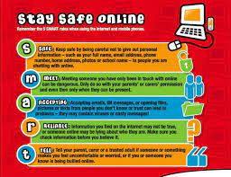
Together we can ALL stay safe online.

Written by the Online Committee at Horncastle Primary School.

