LAND BEFORE TIME HOMEWORK

There are lots of tasks to choose from below. Each week, select one of these to do alongside your maths homework.

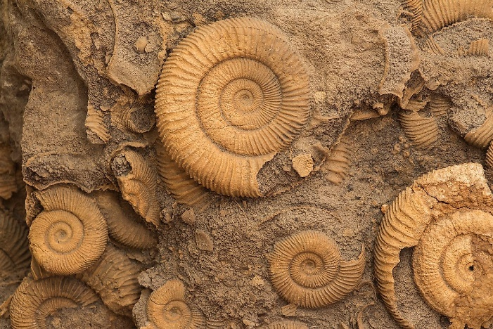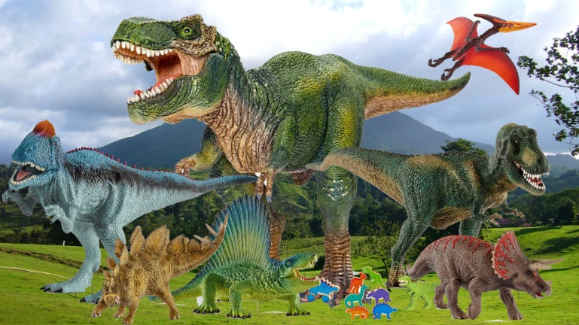

Using the Internet or books, find and write 5 interesting facts about a chosen dinosaur.

Write your own quiz on dinosaurs, remember to write the answers too.

Choose a dinosaur and draw a detailed drawing of it. You could add labels to show its key features.

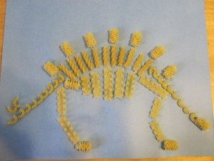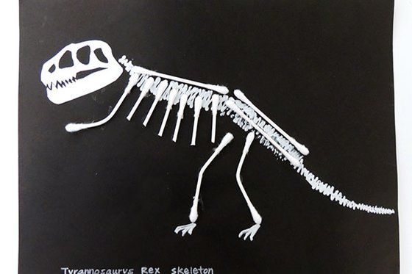

Choose the skeleton of a dinosaur and have a go at making it in a creative way. You could use pasta or cotton buds!

Choose an animal and research how it has evolved and changed over time. How has it adapted to its environment?

Create some dinosaur ‘top trumps’ games. Choose a selection of dinosaurs and a list of features to compare.

Research a famous Palaeontologist and write some key facts about them.